Ideation Phase
Problem Statement

Date | 18 October 2022
Team ID | PNT2022TMID00751
Project Name | AI-Powered Nutrition Analyzer For Fitness Enthusiasts
Maximum Marks | 2 Marks

Problem Statement

In day-to-today life, either insufficient or plentiful intake of nutrients results in nutritional imbalance in our health leading to various diseases.In India, because of unhealthy food, most young people are dying due to obesity, type 2 diabetes, heart disease, high blood pressure, and stroke. Nutritional Analysis ensures that the food has optimal requirement of vitamins and minerals wherein the examining of nutrition in food helps in understanding about the fat proportion, carbohydrates dilution, proteins, fiber, sugar, etc.The main aim of the project is to building a model which is used for classifying the fruit depending on different characteristics like colour, shape, texture etc. Here,the user can capture the images of different fruits and then the image will be sent to the trained model. The model analyses it and detect the nutrition based on the fruits like Sugar, Fibre, Protein, Calories, etc..

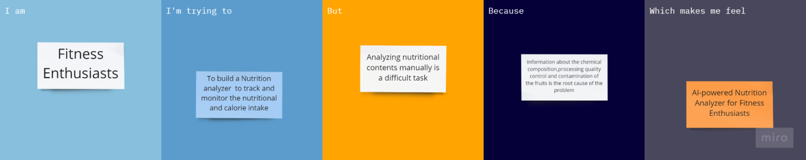

Problem  Statement (PS) | I am  (Customer) | I’m trying to | But | Because | Which makes me feel
PS-1 | Fitness | Build a | Analyzing | Information | AI-powered Nutrition
 | enthusiasts | nutrition | nutritional | about the | Analyzer for Fitness
 |  | analyzer | contents | chemical | Enthusiasts
 |  |  | manually is | composition,
 |  |  | a difficult | processing
 |  |  | task | quality
 |  |  |  | control and
 |  |  |  | contaminatio
 |  |  |  | n of the
 |  |  |  | fruits is the
 |  |  |  | root cause of
 |  |  |  | the problem

